Post | Station Manager Protection | Post No | CBUSSA021
Line Manager | Group Manager Prevention & Protection | Location | Protection Department
Directorate | Prevention & Protection | Responsible for: | Fire Safety Officers (Watch Managers, Firefighters, Non Uniformed, RDS)
Scale | Station Manager | Current Salary | £57,402 pa
Duty System | 42 hour duty system | Status of Post | Permanent

1 Job Purpose

  - To manage and co-ordinate the fire safety activities of a specified function across the county.

  - Carry out high level fire safety audits/inspections of premises and plans in accordance with laid down Fire and Rescue Service policies.

  - Provide a high level of technical fire safety advice and manage the performance of Fire Safety Enforcement and to promote fire safety awareness in the community.

  - As required by the Service you may be expected to provide operational cover in line with EFSM2.

- Major Tasks – Fire Safety

  - Prepare reports on audits/inspections in accordance with Fire and Rescue Service policy.

  - Carry out and monitor the enforcement of the fire safety legislation to ensure it is in accordance with legislative and Service policies and procedures. Progress cases to prosecution and/or work with the Service’s legal team.

  - Develop an agreed risk based inspection programme in accordance with the Service’s CRMP.

  - Consultation with building control bodies on the provision of plans, information and queries concerning fire safety in new and altered buildings.

  - Liaison with other enforcing and licensing authorities relating to matters of fire safety and Fire Safety Enforcement.

  - To monitor the performance of Fire Safety Enforcement policies and strategies and prepare regular monitoring reports as directed.

  - In liaison with the Prevention and Protection Team, promote fire safety awareness in the community. Provide fire safety advice and education to the community, giving lectures, presentations, talks and demonstrations as required.

  - To ensure that any information obtained during the course of audits/inspections in relation to special or significant risks is brought to the attention of the relevant departments in accordance with Fire and Rescue Service policies.

  - To make recommendations to the Group Manager – Prevention on any changes necessary to fire safety policies, procedures, legislation and other fire safety documentation to enable these to be kept up to date and relevant.

  - To co-ordinate Fire Safety Enforcement training, in accordance with policies and procedures.

  - To attend meetings with other agencies in support of Fire Safety Enforcement, Building Regulations and Planning..

  - Assisting with special projects, putting forward fire safety and operational requirements.

  - Investigate the causes of fires and false alarms and report these in accordance with Service policies.

  - Identify the training and development needs of fire safety personnel and in conjunction with the Group Manager – Prevention and the Development Safety and Risk Department to ensure that individual development and training needs are met.

  - Lead, monitor and support to resolve operational incidents – Incident Command System. Resume responsibility and implement actions to support those involved in the incident. Debrief the staff involved following resolution of an incident.

2.17 To ensure an appropriate response to all consultations within designated timescales and provide detailed reports on any shortfalls to the Group Manager – Prevention. To monitor the performance of building regulation and planning policies and strategies and prepare regular monitoring reports as directed.

2.18 Assisting with special projects putting forward fire safety and operational requirements.

- Major Tasks – Operational

  - Provide operational cover and attend incidents as necessary, assuming command where appropriate and in accordance with Brigade Orders and Standing Operating procedures.

  - Participate in such activity as may be required to maintain your operational competence and enable your deployment to meet the exigencies of the Service.

Job Activities

  - Co-operate with, and ensure that, effective communication and liaison is established with other functional areas within the Fire and Rescue Service.

  - To represent the Fire and Rescue Service on committees, and to attend seminars and other relevant meetings as required, reporting any outcome to the Group Manager – Prevention.

  - To produce and present management reports regarding relevant matters, including costs and resources, making recommendations as appropriate.

  - Operate within the Fire and Rescue Service’s financial systems and procedures.

  - To manage the process of training, development and IPDR’s for staff.

  - To deliver talks and lectures to outside organisations and bodies as and when required.

  - To assist with the collation of returns for statistical purposes as required.

  - To produce Action Plans to deliver the Fire Safety ‘Prevention’ strategic plan.

  - To develop and implement agreed strategies for Fire Safety Enforcement.

  - Obtain relevant information to assist local decisions and provide information to others within the organisation to support decision making, including participation in the Technical Standards Group to provide reports and recommendations as required.

  - Ensure that the methods to record and store information are legally compliant and appropriate in accordance with Fire Service policies.

  - Conduct accurate analysis of information and use this effectively to support decision making.

  - Advise and inform others, including Group Manager – Prevention, on a regular basis.

  - Implement, in consultation with appropriate line manager, personal development plan to continuously improve on own personal performance.

5 Other Tasks

5.1 To ensure that the Brigade policies on equality and diversity at work are implemented, monitored and adhered to at all times, in order to achieve a working environment that promotes equality and diversity. Be sensitive to the feelings and needs of others.
5.2 To carry out such other duties as may be directed, commensurate with the grading
of the post.

5.3 To support the organisation in embedding the ‘core values’, strategic aims and corporate objectives.

5.4 To ensure all duties are carried out in accordance with the Authority’s ICT Security Policy.

5.5 To comply with the Health and Safety responsibilities set out in Appendix A to this job description.

5.6 Maintain proper administrative procedures and records in accordance with Service policy, orders and instructions and submit returns of all work undertaken.

5.7 Maintain discipline in accordance with Fire and Rescue Service Disciplinary policy and procedures.

5.8 Ensure that Fire and Rescue Service policies, procedures and standards are complied with.

5.9 Maintain appropriate standards of conduct and dress of personnel whilst on duty in accordance with Service policy.

5.10 Attend and participate in both internal and external training courses as required.

5.11 To monitor sickness absence amongst staff and take action as required by Brigade Orders.

6 Status of job description

6.1 February 2025

Health & Safety

Station Manager
Reporting to the Group Manager – Prevention and is responsible for,

- Implementing the Brigade health and safety policy within your area of responsibility.

- Bring the health and safety policy to the attention of all staff under your control.

- Ensure all new entrants under your control are properly inducted into the Brigade, which must include an awareness of all precautions and procedures applicable to the job, and the emergency procedures.

- Ensure compliance with all safety precautions that apply to their area of control, including the regulation of contractors.

- Ensure that no person is permitted to operate equipment or carryout hazardous tasks unless they are competent to do so.

- Develop and implement safe systems of work for tasks specific to your area of control, including (but not limited to):
Display Screen Equipment
- drills
- station routine duties
- movement of vehicles

- Ensure compliance with all legal requirements for their area of control including (but not limited to):
- inspection of fire fighting equipment
- safe use of fixed and portable electrical equipment
- safety training for staff
- statutory inspections of plant and equipment
- provision of first aid equipment
- control of hazardous substances

- Ensure that any responsibilities delegated to staff are clearly identified.

- Ensure that access to Brigade property under your control by visitors or members of the public are limited to safe areas.

- Ensure risk assessments for equipment, tasks, premises and manual handling activities are conducted, regularly reviewed and compliance with any further control measures identified.

- Conduct regular safety briefings with immediate subordinates to ensure health and safety remains high profile.

- Foster and maintain a positive safety culture.

- Monitor activities at drills, incidents and training to confirm compliance with Brigade safety standards and training inputs.

- Report and investigate accidents, near misses and dangerous occurrences to your staff or other persons on premises that you control.

- Conduct reviews of safety management within your area of responsibility to ensure continual improvement.

- Report to your immediate line manager any shortcomings in the Brigade’s safety management system that you cannot solve yourself.

Performance Qualities and Attributes
Middle Manager Function

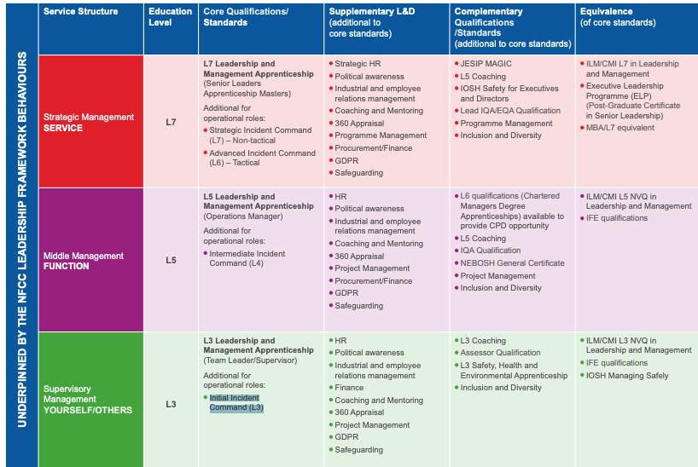

Person Specification

ESSENTIAL | DESIRABLE
Have completed, or be working towards, the ILM Level 5 Leadership and Management qualification, or equivalent | NEBOSH General Certificate or similar qualification in health and safety.
Demonstrate experience of applying leadership and management skills in a fire and rescue service or similar operational environment | Experience in embedding inclusion and diversity initiatives within a fire and rescue service.
Commit to work towards the Level 4 Diploma in Fire Safety | Qualification or training in equality, diversity and inclusion best practices.
Understanding of developing, implementing, and monitoring plans related to public safety and risk reduction. | Experience in supporting the delivery of projects, with a track record of delivering outcomes on time and within budget
Experience of managing a team | Experience of managing a Fire Safety function
Understanding of managing audit and compliance processes, including the preparation of documentation, performance evaluation, and action planning. | A working knowledge of project management methodologies
Understanding of NFCC Fire Standards and their application within the fire sector | Corporate Membership of the Institution of Fire Engineers or similar professional qualification
Proven experience in developing and maintaining partnerships with external agencies, including local authorities, emergency services, and national bodies.

Ability to influence and negotiate with stakeholders at all levels to achieve shared objectives.

Strong decision-making skills, particularly in high-pressure situations, supported by evidence-based analysis

Ability to assess complex challenges and develop clear, structured action plans to address them

Proactive in identifying risks and opportunities, with a focus on long-term service improvement

Familiarity with program management methodologies and best practices

Strong written and verbal communication skills, with the ability to produce high-quality reports, policies, and presentations

Experience of using Microsoft Office application software

Effective in engaging and influencing a diverse range of stakeholders, from operational teams to senior leadership

Ability to interpret data, identify trends, and make evidence-based recommendations

Competency in using digital tools and software for data analysis and reporting.

Full UK driving license

Experience of operating in a performance management environment

High standard of motivation and task management, with proven problem-solving ability

Excellent time management skills with a flexible approach to working hours including a commitment to working occasional weekends and evenings

Experience of managing Operational Incidents

